# DriverPass System Design Document

Grace A. Wright

## UML Diagrams

### UML Use Case Diagram

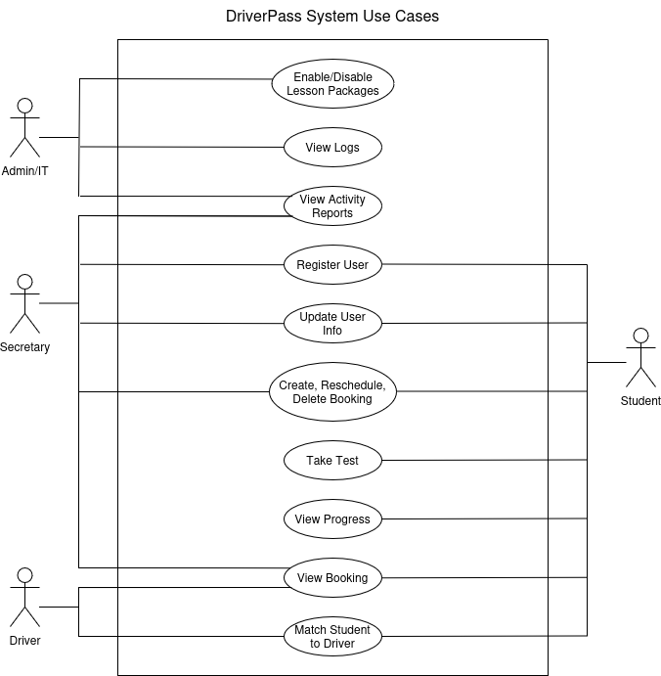

### UML Activity Diagrams

*[You were asked to choose* ***two*** *use cases and create* ***two*** *activity diagrams, one for each use case. Please insert* ***both*** *of your activity diagrams here. Check to make sure that you included appropriate components and symbols and that your design meets the client’s needs.]*

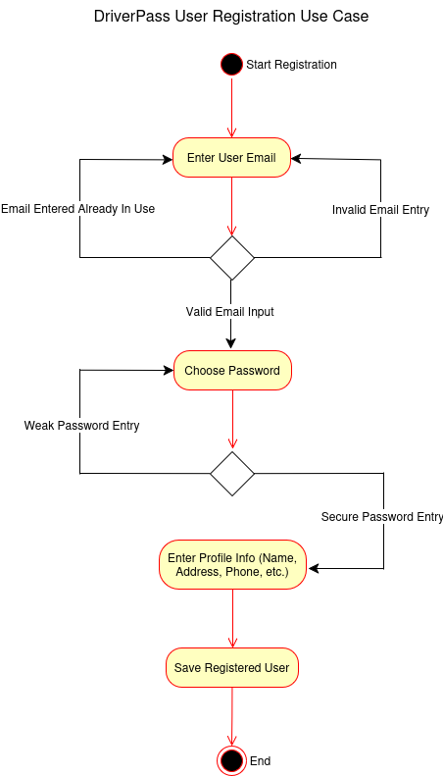

### 

### UML Sequence Diagram

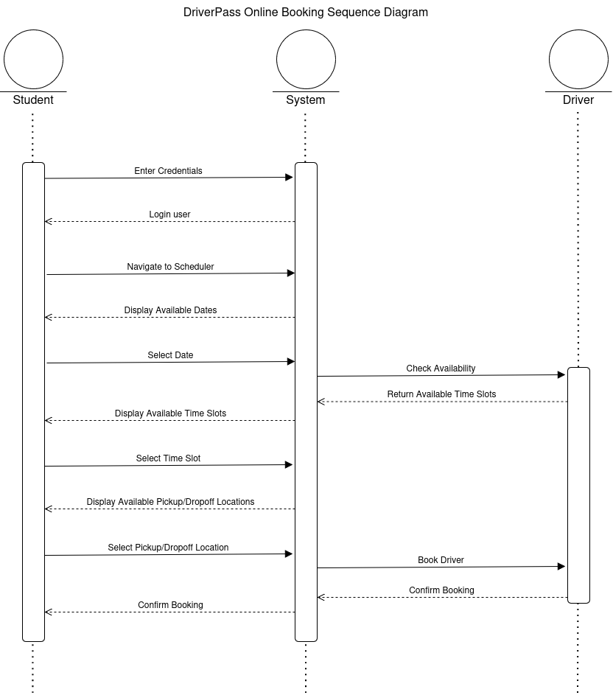

### UML Class Diagram

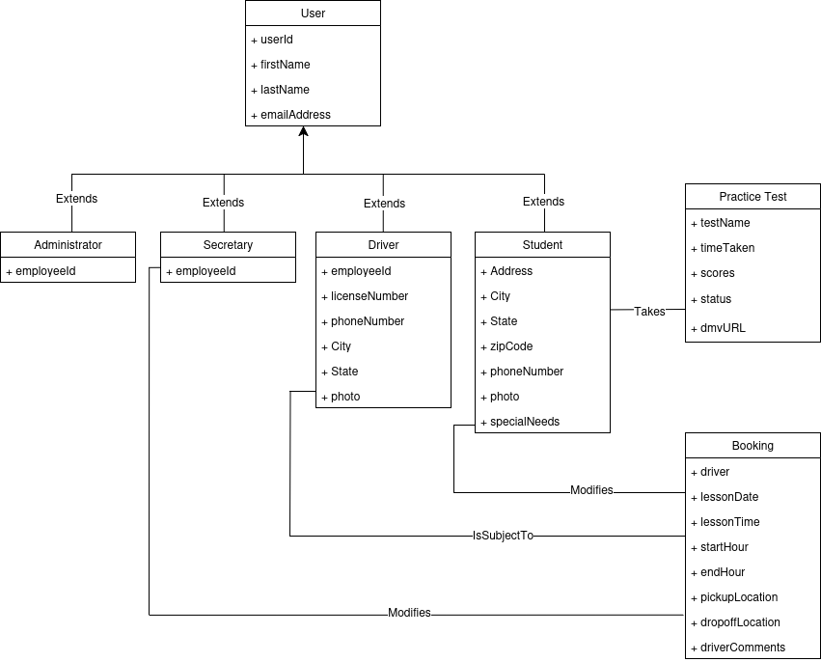

## Technical Requirements

The web application is intended to run on a cloud-based server, such as through Amazon Web Services or Google. This means that the IT admin will not be tasked with maintaining in-house servers, which can quickly become a monumental task. The servers will likely be expected to run on Unix, which will prioritize system performance.

The application will need to be accessible via the most popular web browsers, i.e. Chrome, Edge, Safari, and Firefox. A mobile version of the site will need to be developed for users browsing on their mobile devices. Care should be taken to ascertain that the web application can deploy properly on systems running common operating systems (Windows, MacOS, Linux, and Android).

The system will also need to establish connectivity with a DMV database to perform checks and updates on DriverPass’s online learning content, i.e. the information in practice tests needs to be kept up-to-date. An in-house database will also be necessary for storing our own information, such as said tests, as well as users and their information.